**Lab practical 05**

**COA**

**Question:**

**Write a program in assembly language to perform Division of 8-bit data.**

**Code:**

**org 100h**

**mov al,98h**

**mov bl,10h**

**idiv bl**

**mov bl,al**

**mov bh,ah**

**and al,0f0h**

**shr al,4**

**add al,30h**

**cmp al,39h**

**jle print_first_digit1**

**add al,7**

**print_first_digit1:**

**mov dl,al**

**mov ah,02h**

**int 21h**

**mov al,bl**

**and al,0fh**

**add al,30h**

**cmp al,39h**

**jle print_second_digit1**

**add al,7**

**print_second_digit1:**

**mov dl,al**

**mov ah,02h**

**int 21h**

**mov al,bh**

**and al,0f0h**

**shr al,4**

**add al,30h**

**cmp al,39h**

**jle print_first_rem_digit**

**add al,7**

**print_first_rem_digit:**

**mov dl,al**

**mov ah,02h**

**int 21h**

**mov al,bh**

**and al,0fh**

**add al,30h**

**cmp al,39h**

**jle print_second_rem_digit**

**add al,7**

**print_second_rem_digit:**

**mov dl,al**

**mov ah,02h**

**int 21h**

**OUTPUT:**

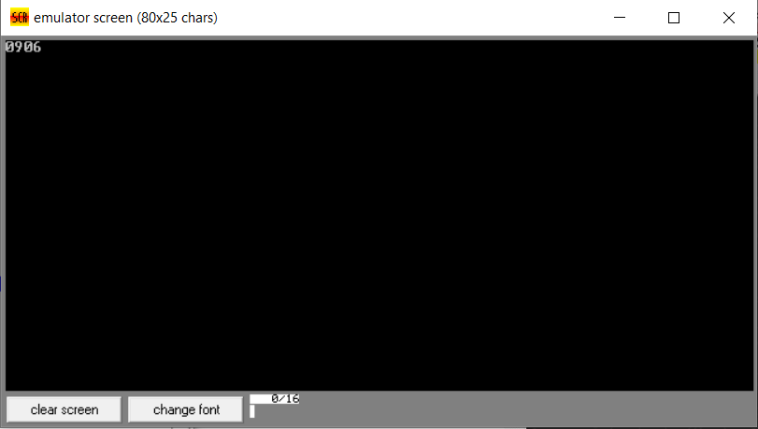

**Question:**

**Write a program in assembly language to perform division of 16-bit data.**

**CODE:**

**org 100h**

**mov ax,1780h**

**mov bx,1000h**

**div bx**

**mov bx,ax**

**mov cx,dx**

**mov ah,ch**

**and ah,0f0h**

**shr ah,4**

**add ah,30h**

**cmp ah,39h**

**jle print_high_nibble32**

**add ah,7**

**print_high_nibble32:**

**mov dl,ah**

**mov ah,02h**

**int 21h**

**mov ah,ch**

**and ah,0fh**

**add ah,30h**

**cmp ah,39h**

**jle print_low_nibble32**

**add ah,7**

**print_low_nibble32:**

**mov dl,ah**

**mov ah,02h**

**int 21h**

**mov ah,cl**

**and ah,0f0h**

**shr ah,4**

**add ah,30h**

**cmp ah,39h**

**jle print_low_nibble24**

**add ah,7**

**print_low_nibble24:**

**mov dl,ah**

**mov ah,02h**

**int 21h**

**mov ah,cl**

**and ah,0fh**

**add ah,30h**

**cmp ah,39h**

**jle print_high_nibble24**

**add ah,7**

**print_high_nibble24:**

**mov dl,ah**

**mov ah,02h**

**int 21h**

**mov ah,bh**

**shr ah,4**

**add ah,30h**

**cmp ah,39h**

**jle print_high_nibble**

**add ah,7**

**print_high_nibble:**

**mov dl,ah**

**mov ah,02h**

**int 21h**

**mov ah,bh**

**and ah,0fh**

**add ah,30h**

**cmp ah,39h**

**jle print_low_nibble**

**add ah,7**

**print_low_nibble:**

**mov dl,ah**

**mov ah,02h**

**int 21h**

**mov ah,bl**

**shr ah,4**

**add ah,30h**

**cmp ah,39h**

**jle print_high_nibble2**

**add ah,7**

**print_high_nibble2:**

**mov dl,ah**

**mov ah,02h**

**int 21h**

**mov ah,bl**

**and ah,0fh**

**add ah,30h**

**cmp ah,39h**

**jle print_low_nibble2**

**add ah,7**

**print_low_nibble2:**

**mov dl,ah**

**mov ah,02h**

**int 21h**

**mov ah,4ch**

**int 21h**

**OUTPUT:**

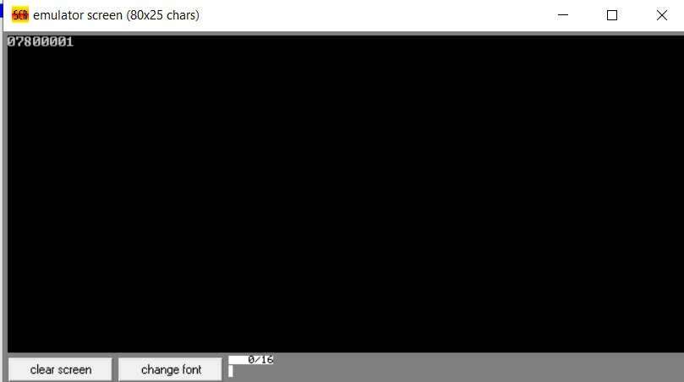

**GITHUB:**

[**https://github.com/srijachakilam15/COA/blob/main/lab%20practical%2003.docx**](https://github.com/srijachakilam15/COA/blob/main/lab%20practical%2003.docx)